The dataset **opl_female.csv** contains data on female competitors for various powerlifting tournaments. These tournaments consist of 3 different powerlifting events which are the bench, squat, and deadlift events all measured in Kilograms. The motivation of this data analysis is to explore the relationship between bench and squat weights (in Kilograms) to gain insights into the performance patterns of the competitors. For this activity, we will specifically focus on weights from 25-year-old female competitors.

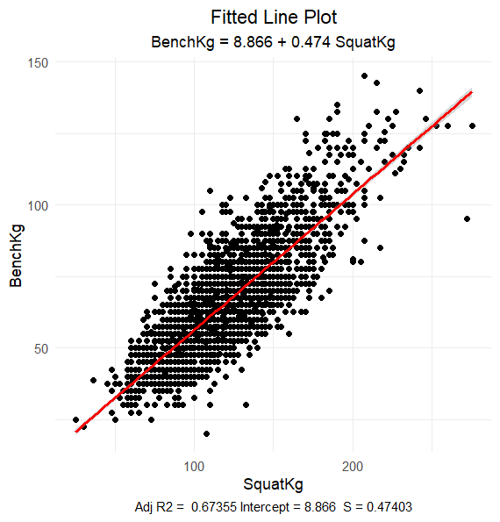

1. What is the explanatory variable in this situation? What is the response variable? What type are both variables? What are the units?
2. What does each point in the scatterplot represent?
3. Report the least squares regression equation for predicting squat weight from bench weight.
4. Suppose that you were interested in using this regression model to predict the Bench weight for other age ranges within female competitors. What assumption about your data would you need to make?
5. Sara Crews had a 120.0 squat weight. What is her predicted bench weight? Regardless of your answer to the previous question, continue to use the equation from question 3.

1. Crews’ bench weight was 65.00 kilograms. How far off was the model prediction? Explain why we might see this observation.
2. Interpret the slope of the model in the context of the application. Be sure to be mindful of the units.
3. Interpret the intercept of the model in the context of the application.
4. Is the intercept interpretation meaningful? Explain.
5. What percent of the variation in SquatKg is explained by the model using BenchKg? What is the sample correlation?
6. Based on your comprehensive analysis, describe the relationship between bench weights and squat weights using multiple pieces of information from your findings.